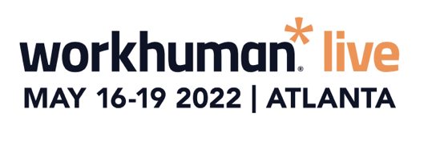
SIMPLY COPY AND PASTE THE TEXT BELOW INTO AN EMAIL:
Dear [NAME]
I’m requesting approval for the team to attend Workhuman® Live 2022, May 16-19, at the Georgia World Congress Center in Atlanta, Georgia.
Why Workhuman Live?
It’s more than a conference. Workhuman Live is the only HR conference addressing the most important issues in work – including the Great Resignation, navigating hybrid workforces, and driving diversity, equity and inclusion. The conference attracts powerful, award-winning academic and business leaders who aren’t afraid to tackle the tough issues facing our industry. And the speakers represent some of the most admired and innovative thinkers of today – in fact, Malcolm Gladwell and Priya Parker are already on the agenda.
There’s a rich offering of breakout sessions across 8 learning tracks on the topics meaningful to the business challenges we’re currently tackling. You can check out the initial speakers here.
How will this benefit [COMPANY NAME]?
Every year, the global movement to bring more humanity to today’s workplace comes to life at this event. And what’s better than getting to attend? Bringing a team.

We could leverage Workhuman Live as the opportunity for an offsite or just a chance to grow together. After two years of supporting [company name]’s people through the pandemic, it would be a great opportunity for our team to recharge and renew our own inspiration while getting the knowledge, tools, and experience to bring more resilience, engagement, and humanity back to the company.

For the depth and breadth of the content offered, there’s no conference priced this low that delivers half as much. And we’ll leave ready to take everything we learned and implement it. Since there would be more of us, we could divide and conquer the agenda and have a bigger impact when we return.

There is a teams program and benefits package with cost savings if we go together.
Forward-leaning organizations have long foreseen a shift in the modern workplace to provide a more human employee experience that strengthens connections between people and teams, and, ultimately, drive stronger employee and company performance.

Workhuman Live 2022 attendees will also receive Professional Development Credits (PDCs). The last time the event was held in-person, attendees were awarded PDCs from SHRM, HRCI, HRPA, ATD, and WorldatWork toward their recertification.
While at Workhuman Live 2022, the team will attend sessions that I believe will benefit key work culture initiatives at [COMPANY NAME] including:
  - [add project or initiative]
  - [add project or initiative]
  - [add project or initiative]
Here’s a breakdown of the teams approximate per-person conference expenses:
- Registration:
  - Airfare:
  - Transportation:
  - Hotel: <reference the average negotiated rates of $250 per night>
  - Meals: <reference all onsite meals are included in the conference registration>
  - Incidentals:
Total conference cost for the team of ______ , or _______ per person.
When we return from Workhuman Live 2022, we will prepare a post-conference summary, including detailed recommendations that can further our [XYZ initiatives]. We’ll also receive an Action Plan from Workhuman® – including key findings and insights – that can be shared with the team.
Workhuman Live 2022 will help us continue the momentum of building a more human work culture at [COMPANY NAME] – one that differentiates our company so we can better attract top talent and retain the valuable employees we have today.
Thank you for your consideration.
Regards,
[SIGNATURE]

