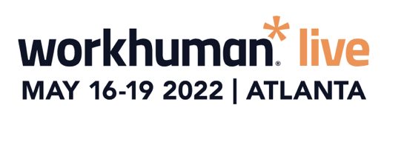
SIMPLY COPY AND PASTE THE TEXT BELOW INTO AN EMAIL:
Dear [NAME]
I’m requesting approval to attend Workhuman® Live 2022, May 16-19, at the Georgia World Congress Center in Atlanta, Georgia.
Why Workhuman Live?
It’s more than a conference. Workhuman Live is the only HR conference addressing the most important issues in work – including the Great Resignation, navigating hybrid workforces, and driving diversity, equity and inclusion. The conference attracts powerful, award-winning academic and business leaders who aren’t afraid to tackle the tough issues facing our industry. And the speakers represent some of the most admired and innovative thinkers of today – in fact, Malcolm Gladwell and Priya Parker are already on the agenda.
There’s a rich offering of breakout sessions across 8 learning tracks on the topics meaningful to the business challenges we’re currently tackling. You can check out the initial speakers here.
How will this benefit [COMPANY NAME]?
Forward-leaning organizations have long foreseen a shift in the modern workplace to provide a more human employee experience that strengthens connections between people and teams, and, ultimately, drive stronger employee and company performance.
These are the types of breakthrough insights I’ll gain at Workhuman Live – and can bring back and put to work at [COMPANY NAME]. Workhuman Live 2022 will give me proven strategies and actionable ideas on how we can help motivate our workforce, increase employee retention and engagement, and boost productivity.
Workhuman Live 2022 attendees will also receive Professional Development Credits (PDCs). The last time the event was held in-person, attendees were awarded PDCs from SHRM, HRCI, HRPA, ATD, and WorldatWork toward their recertification.
While at Workhuman Live 2022, I will attend sessions that I believe will benefit key work culture initiatives at [COMPANY NAME] including:
  - [add project or initiative]
  - [add project or initiative]
  - [add project or initiative]
Here’s a breakdown of my approximate conference expenses:
- Registration:
  - Airfare:
  - Transportation:
  - Hotel: <reference the average negotiated rates of $250 per night>
  - Meals: <reference all onsite meals are included in the conference registration>
  - Incidentals:
Total conference cost of ______.
When I return from Workhuman Live 2022, I will prepare a post-conference summary, including detailed recommendations that can further our [XYZ initiatives]. I’ll also receive an Action Plan from Workhuman® – including key findings and insights – that I can share with the team.
Workhuman Live 2022 will help me continue the momentum of building a more human work culture at [COMPANY NAME] – one that differentiates our company so we can better attract top talent and retain the valuable employees we have today.
Thank you for your consideration.
Regards,
[SIGNATURE]

